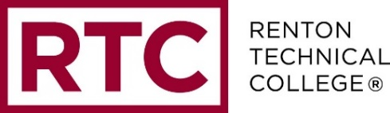

College Council Meeting
Monday, February 26, 2018 (I-202)
____________________________________________________________________________

AGENDA

1. Welcome and introductions All

2. Review and approval of January minutes All

3. Review of mid-year unit plan updates Neal Parker

4. Update on monitoring report and scorecard Michelle Campbell
- Monitoring report draft – May 1
- Report sent to College Council – May 11
- KPIs scored at College Council – May 21
- Report finalized – May 25
- Report shared with campus and board of trustees – June 13

5. Surveys update Neal Parker/Jichul Kim
- Employee satisfaction survey
- Employee engagement survey results
- CCSSE
- Spring surveys

6. Guided pathways update Michelle C/Angel Reyna
- Status of scale of adoption assessment tool
- Q and A from all-college meeting discussion

College Council 2017-18 Goals
- Monitor the strategic plan implementation process
- Increase the communication and transparency of college governance across campus
- Monitor progress towards preparation for next year seven accreditation visit

Future Meetings: Meetings will occur on the third Monday of every month from 2:30-4:00 p.m. in I-202, unless otherwise stated. Meeting schedule is as follows:

- March 19
- April 23
- May 21
- June 18

NOTE: All meetings for the 2017-18 academic year are listed on the College Council calendar in SharePoint as well as on the College Council webpage located here: http://www.rtc.edu/governance-meetings

